**Assignment 2: The IT World**

1. **Team profile:**

**Team name: NoobsTeam**

**Personal information:**

* **Nguyen Huu Gia Thanh (s3932584):** Ho Chi Minh City is where I was born. My family has lived in Hanoi, Vietnam's capital, since I was in third grade since that is where my father's extended family lives and works. I graduated from Chu Van A high school, which is one of Vietnam's most famous and well-known high schools, particularly in Hanoi. Following that, I received a 27 on the national exam. My mother tongue is Vietnamese, and I can also communicate in English. There are several advantages to learning English, including the ability to converse with more international acquaintances. Furthermore, because so much orthodox information is written in English, it really assists me when I need to conduct research. Aside from that, I enjoy playing basketball**.** My mother took me to the basketball court when I was a youngster, and I watched people having fun with each other via how they played and worked as a team, and the enthusiasm for the orange ball came to mind. I seldom exercise at home, so after school, my bestie and I always go to the court near our houses to unwind and play basketball. Furthermore, I am a major fan of League of Legends, one of the world's most popular MOBA games. I used to play it a lot with my secondary school friends, but since I started high school, I have had to learn to manage my time more effectively, so I now play games once or twice a week since I have so many other things to worry about. I chose to pursue information technology for a variety of reasons. For starters, it permits me to pursue a variety of employment routes. To work as a game developer, a cybersecurity expert, or a web developer, for example. Now, I want to be a cybersecurity professional, but as my studies develop, I may get interested in other sectors that are more appropriate for me. Second, according to the fourth industrial revolution, any creative technology may fall behind the times at the speed of light, and I appreciate working in an atmosphere that always challenges me to keep learning. Finally, like everyone else in the world, I study and work to pursue my passion while still earning a living, and there is nothing better than doing what you enjoy while also earning money. I have been intrigued about my cousin's writing stuff on his computer since I was in seventh school. I was curious about the language he was using until he informed me, he was developing software for his homework. By displaying some of his works, he expanded my imagination. He went on to say that all colorful pages and games are the result of a logical mix of algorithms created by web and game creators. I was also amazed that he hacked the game by inserting some short code into the software, and I hoped that one day I might be able to do the same. After that moment, I began to like programming and began looking for basic programs that aided me a lot in high school.
* **Doan Duy Bach (s39326953)**: First and foremost, my name is Doan Duy Bach. s3926953 is my student number, and s3926953@rmit.edu.vn is my e-mail address. My hometown is in the Vietnamese province of Thai Nguyen. I am a devout atheist who believes in evolution. This year, I completed 12 years of study, during which time I acquired English. As a result, my primary languages of communication are Vietnamese and English. Reading and sports including football, badminton, and table tennis are two of my favorite pastimes. I currently own a goldfish as a pet. I do not have any IT experience right now because I am still new to the field, but I aim to obtain more in the future. Coding is my favorite IT-related pastime. I began coding when I was thirteen years old. At the time, I was enrolled in MindX, a well-known technological school, for an online Python coding course. I learnt a lot of code knowledge within a few weeks of studying, and I felt delighted anytime I completed a coding assignment, therefore coding became my passion associated with IT from that point forward.
* **Don Tuan Duong (s3927233):** I was born in Hanoi, Vietnam's capital city. During my 12 years of education, I acquired various languages, but the ones I use the most currently are Vietnamese, my home tongue, and English. I am presently a first-year Information Technology student at RMIT (Royal Melbourne Institute of Technology) University Hanoi. The world of computers has always captivated me, and I have always wondered how such a little person can do so much. I spend much of my leisure time with a friend playing video games, and I also participate in sports and exercise to stay in shape. I used to play a lot of games on my parents' computer when I was a kid. Since then, I have always been curious about how computer games, websites, and other apps are created. As a result, I realized that one of the disciplines I want to pursue after high school is Information Technology. As I progressed through high school, I saw documentaries on computer science pioneers such as Bill Gates, Steve Jobs, and others. In addition, I study about the computer's components, how they function, and how data is stored, among other things. RMIT is one of the greatest institutions in Vietnam for IT students, which is why I selected it as my first choice. I want to improve my English abilities and learn more about coding and computer systems at RMIT.
* **Thai Phuc Nguyen (s3926861):** I am only a first-year student at RMIT, having recently graduated from high school. Vietnamese and English are the languages I use, however I learned German in the past. I spend all my leisure time playing computer games and listening to music, although I do occasionally pass the time by writing "novels" about my own plot and characters, but I seldom share them with anyone. I prefer IT because it is practical; understanding IT can help me find a stable job with a respectable salary in the future. In addition, I have always been fascinated by computers and programming since I first used the internet. What began as a simple desire to play on a computer video game became a way of life for me, as I began to discover how the games I was playing were created, for example, utilizing popular game engines such as "unreal engine," and customizing computer games using code and design. Overall, my IT experience is little, since what I have learnt about the subject is only the beginning.

**Team profile:**

* **Nguyen Huu Gia Thanh(s3932584):**
* **-The results of an online Myers-Briggs test:** <https://www.16personalities.com/entj-personality>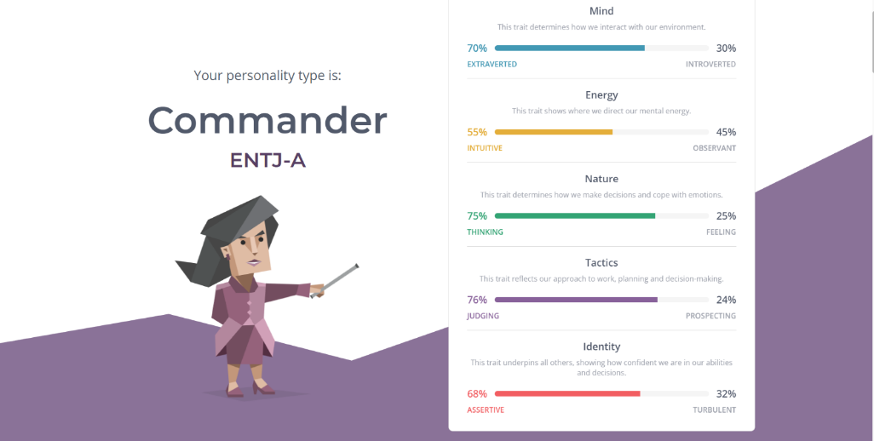

**- The results of an online learning style test:**

Link: <http://www.educationplanner.org/students/self-assessments/learning-styles-quiz.shtml?event=results&A=7&V=6&T=7>



* **The results of Big Five Personality Test:**

Link: <https://www.truity.com/test-results/bigfive/17315/23329842>

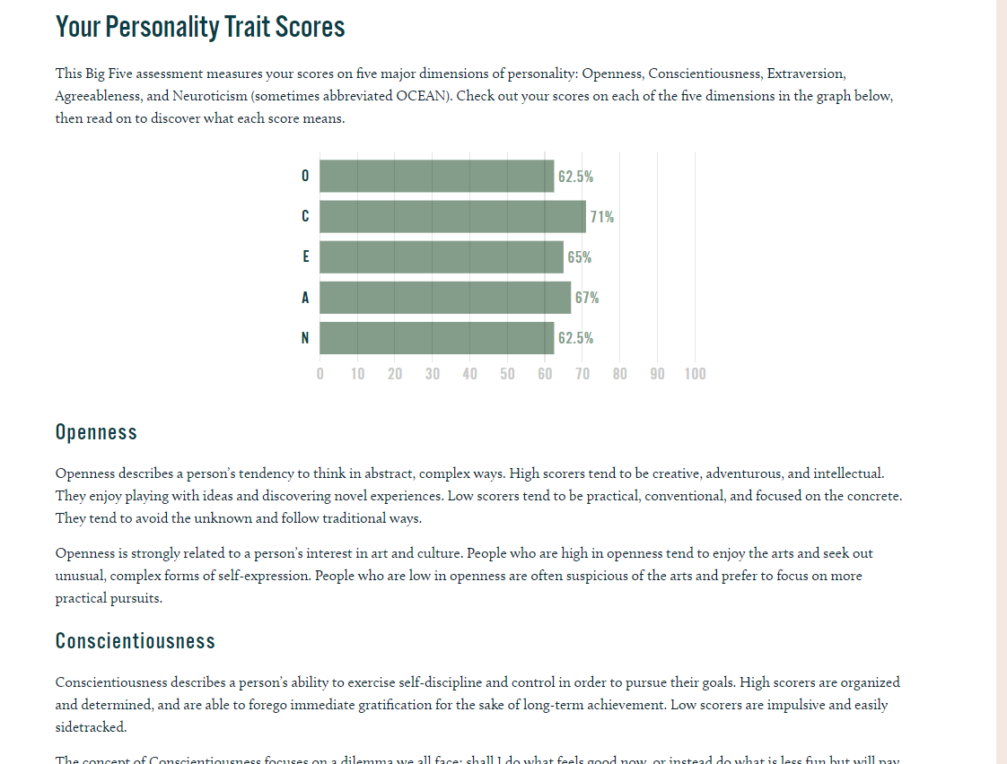

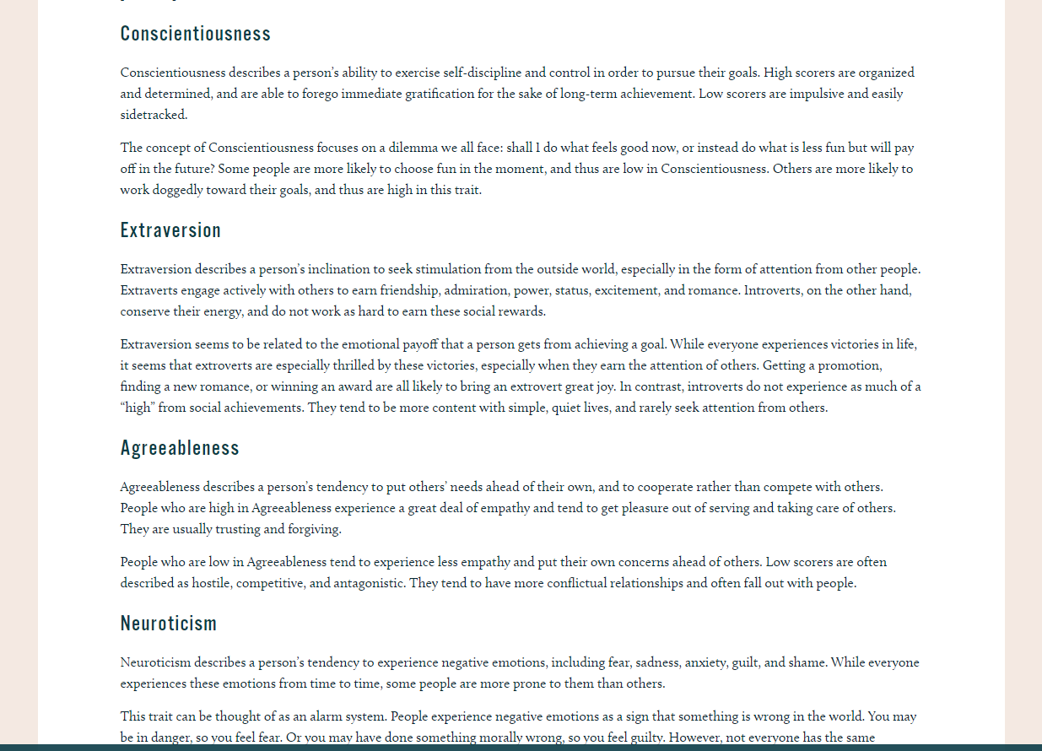

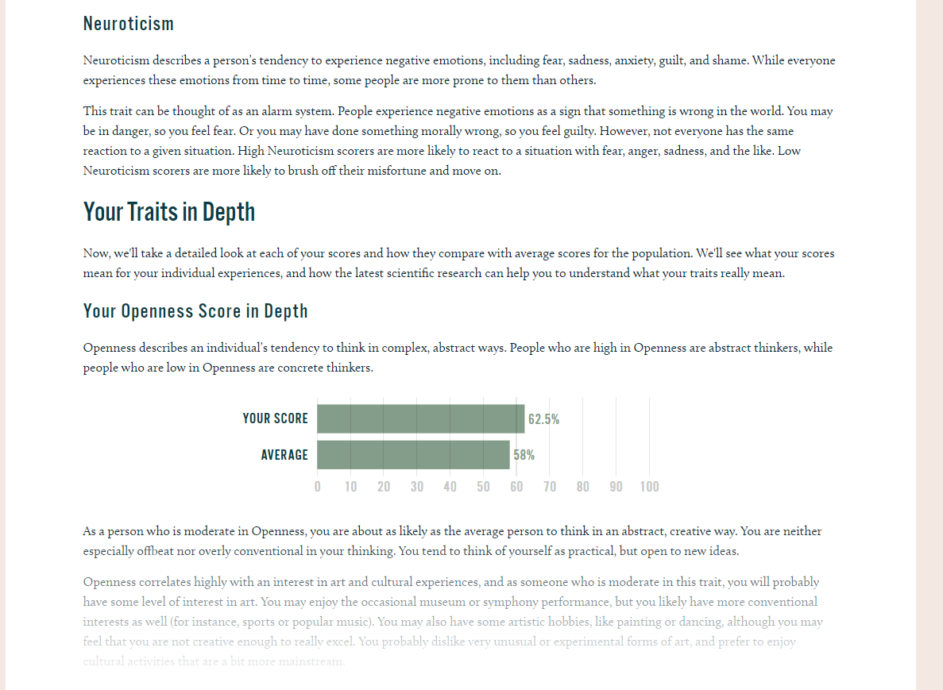

* **Doan Duy Bach (s3926953):**

**- The results of an online Myers-Briggs test:**

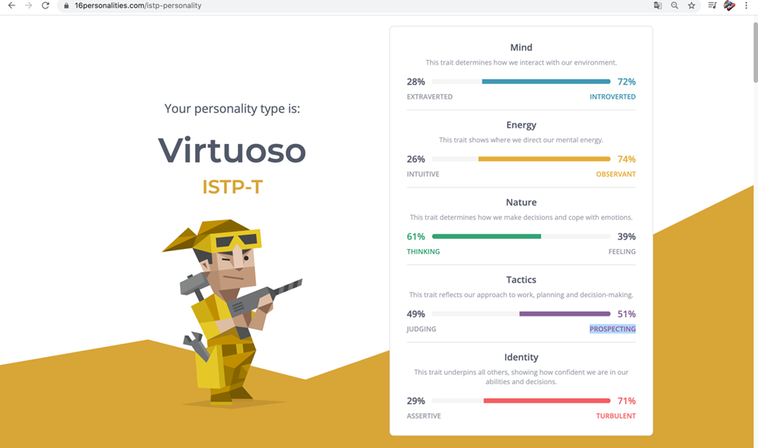

**- The results of an online learning style test:**

**Link:** [**http://www.educationplanner.org/students/self-assessments/learning-styles-quiz.shtml?event=results&A=6&V=9&T=5**](http://www.educationplanner.org/students/self-assessments/learning-styles-quiz.shtml?event=results&A=6&V=9&T=5)

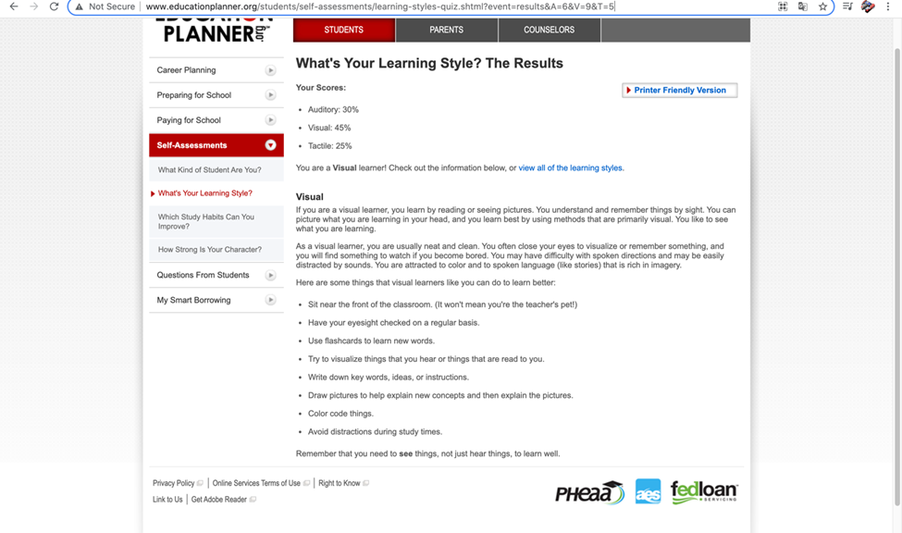

**- The results of one further online test: How create are you?**

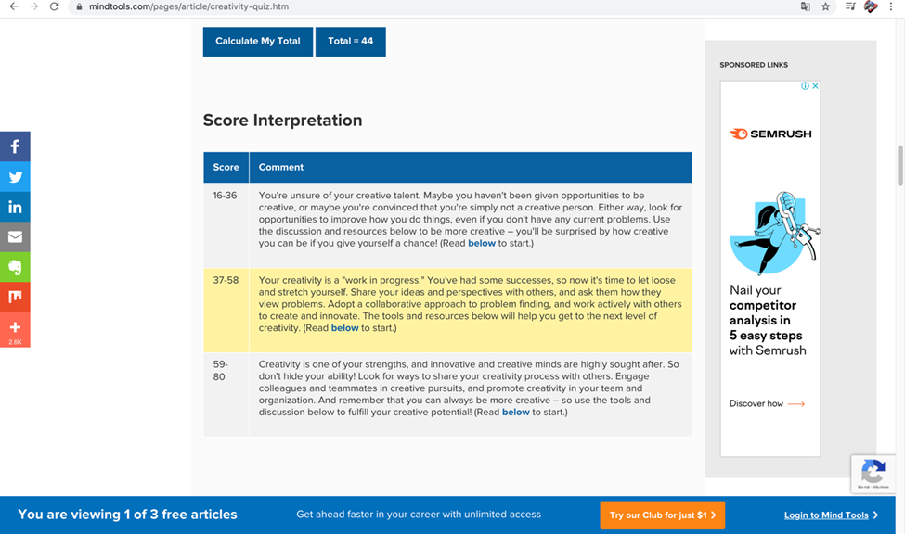

* **Don Tuan Duong (s3927233):**

**MBTI Test results:**

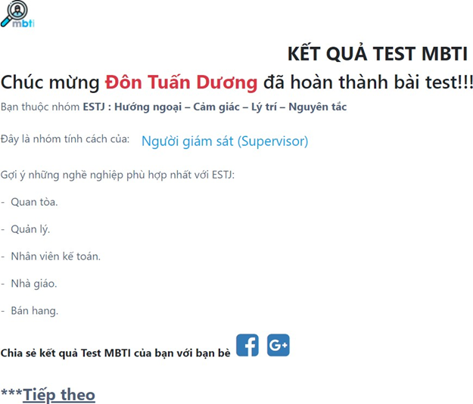

**Learning Style Test results:**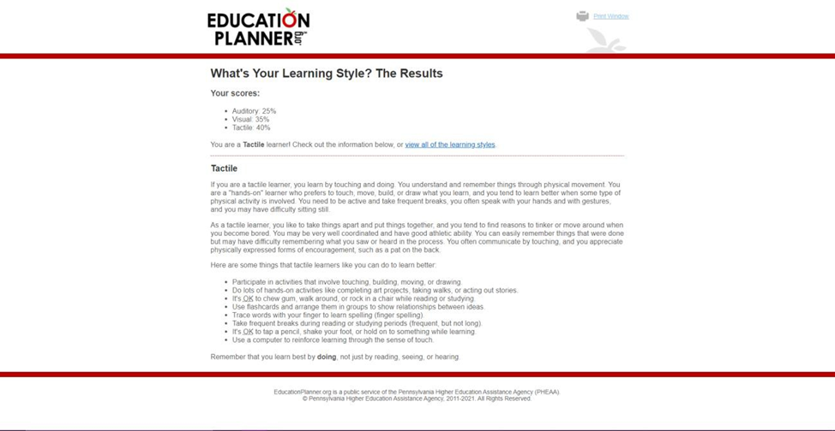

* **Thai Phuc Nguyen (s3926861):**
* **The results of an online Myers-Briggs test**: 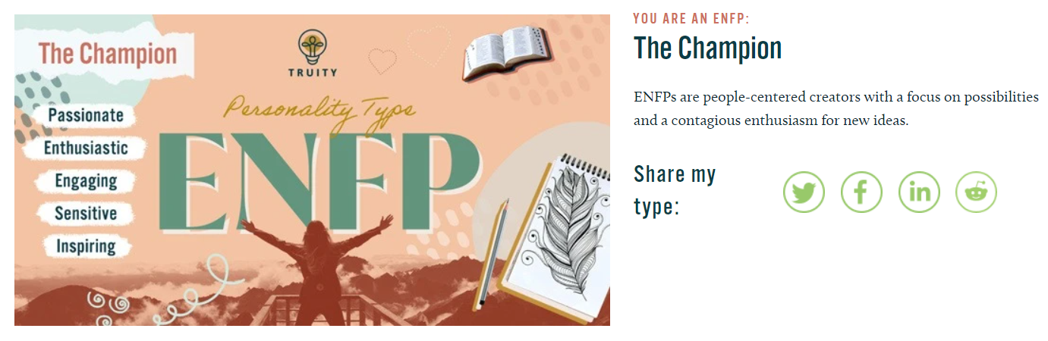 **The results of an online learning style test:** 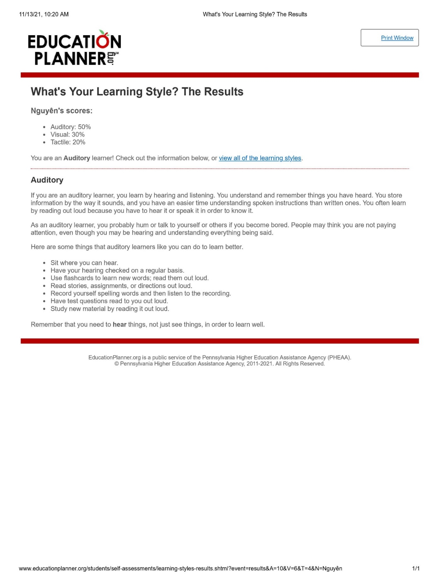
* **An IQ test as an additional test:** 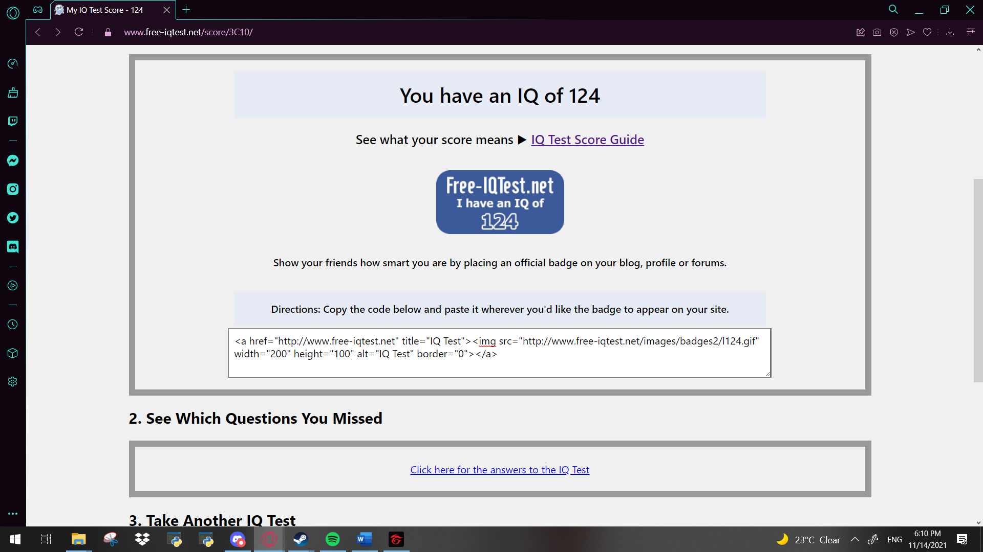

**Understanding on how this information would affect us as a team:**

These tests results taken by my teammates maybe accurate or not, but in my opinion, is irrelevant to how we can work together as a team To be able to work professionally, we must put aside our differences and arguments to come together and finish the task given, so we cant determine anything if we were to look at these tests right here to decide how our group would run, Everyone is given a task, and their job is to finish it on time and accurately.

**Ideal Jobs:**

**Nguyen Huu Gia Thanh:** <https://itviec.com/it-jobs/data-engineer-up-to-2500-no-probation-fpt-software-4614?lab_feature=employer_job>

Job description:

It is specified in this assignment 1 earlier this semester that the job that he thought would be ideal for himself is being a data engineer at the FPT Corporation as seen in the link above.

In a nutshell, he would have to first of all, understand how data is saved and gathered, as well as business processes and applications and according to that, create and manage large-scale streaming data pipelines. Not just that, he needs to meet their rising data demands, he need to design, create, and maintain data marts.

Boiling it down, he needs to have a great understanding of the premise of being a data engineer, which is the knowledge of data engineering, followed by an adequate amount of experience or at the bare minimum have experience on coding languages such as python.

Job requirements:

He must have a basic understanding of data engineering, including data ingestion, data transformation, and data validation, in order to apply for this position. Which he would need at least two years of expertise with public cloud providers such as Amazon Web Services, Microsoft Azure, and others. Aside from his knowledge of Python and its libraries and packages, he may get an advantage over the competition by learning how to use Pandas, NumPy, Flask, and Django. Furthermore, he must be familiar with the Relational Database System (RDBMS), and SQL is required. Not just that, fluency in English in order to speak with consumers on a daily basis is very important to have.

**Doan Duy Bach:** <https://www.vietnamworks.com/full-stack-python-developer-1-1437790-jv/?source=searchResults&searchType=2&placement=1437791&sortBy=date>

Job description:

Once again after reading through his first assignment and reviewing the given link above, it is obvious that he wants to be a full stack python dev. And the name of this position is quite self-explanatory. The developer's job entails creating tools, websites, and mobile apps for the company's products. In addition, he would have the chance to teach rookie developers Python so that he may have a good effect on the next generation of full-stack developers.

Job requirements:

To apply for this job, once again we can see that he needs good knowledge and experience on different coding languages such as python and C. And to keep his software up to date, knowing how to use a “version control” solution such as git would be much required for the position

**Don Tuan Duong:** [https://itviec.com/it-jobs/software-developer-net-c-c-koh-young-technology-inc-](https://itviec.com/it-jobs/software-developer-net-c-c-koh-young-technology-inc-2101) [2101](https://itviec.com/it-jobs/software-developer-net-c-c-koh-young-technology-inc-2101)

Job description:

A software developer for a company called “Koh Young technology”. Which if he applied and was qualified for the job when it was available, he would become a member of the core software development team in said company. He and his team will have to design and maintain an “inspection system” using latest technologies. As a Koh Young Developer, he'll have the opportunity to help shape the design and architecture of a market-leading product while also helping to construct a high-performance infrastructure.

Job requirements:

A similar pattern emerges when it comes to qualifications required to be eligible for the job, compared to the other two team members, which is at least a bachelor’s degree in the field as well as good understanding and experience working with coding languages. In addition to that, an intermediate or higher level of understanding of .NET framework is needed.

**Thai Phuc Nguyen:** <https://www.vietnamworks.com/senior-c-plus-plus-developer-11-1-1-1437668-jv/?source=searchResults&searchType=2&placement=1437669&sortBy=date&utm_source=vnw_homepage&utm_medium=HotCategories&ignoreLocation=true>

Job description:

It is clear that his passion for video games influences a lot on what job he thought would be ideal for himself in the future. A C++ developer for a game company called “gameloft”. He would have to work as a leader of the team he’s given in the company, developing further on current running games as well as executing new ideas for games to help the company grow. Not just that, guiding new interns or teaching them about working with C is also the job he’s required to do.

Job requirements:

At this stage, the name of the position itself is quite self-explanatory already of what he needs to have to be capable of applying for this job. Which is great knowledge and experience on not just C but many other different coding languages. Not just that, good communication skills are crucial to be in a position like this, and so does leadership skills.

**Key comparisons on each person’s ideal job:**

Considering all summaries above, we of course all have chosen jobs related to what we’re following in college because it is reasonable to do so, but different positions and ambitions do appear. Duong have chosen to work in a team, unlike the others whose ambitions goes a little further into leading a whole entire team in a major tech company which might be more realistic, because as we can see, one thing can be seen clearly is throughout all of us, three of us merely only have the basic understanding of coding languages nor have we got any kind of experience working with it, only Bach has taken classes beforehand and got certifications of his understandings.

Overall across the whole team, we can see little to no difference on our career plan for the future after we have graduated from rmit, all have high expectations for what experience and knowledge they’ll gain on the upcoming years at the university.

1. **Tools:**

The link to the website our group has created: <https://doubledepresso.github.io/ezggwp/>

The link to our group’s git repository: <https://github.com/DoubleDepresso/ezggwp.git>

If you read the audit trail aka the commit history of our group’s use of git, you might see there being a few confusions among us while the project is in the making, since we were a little unaware of how to properly collaborate using git instead of just sending each other necessary file via messenger or emails. But we were able to clear the confusion at the end and effectively use git to stay on track on what’s needed to be done and what has been done for our group work and keep things as organized as possible.

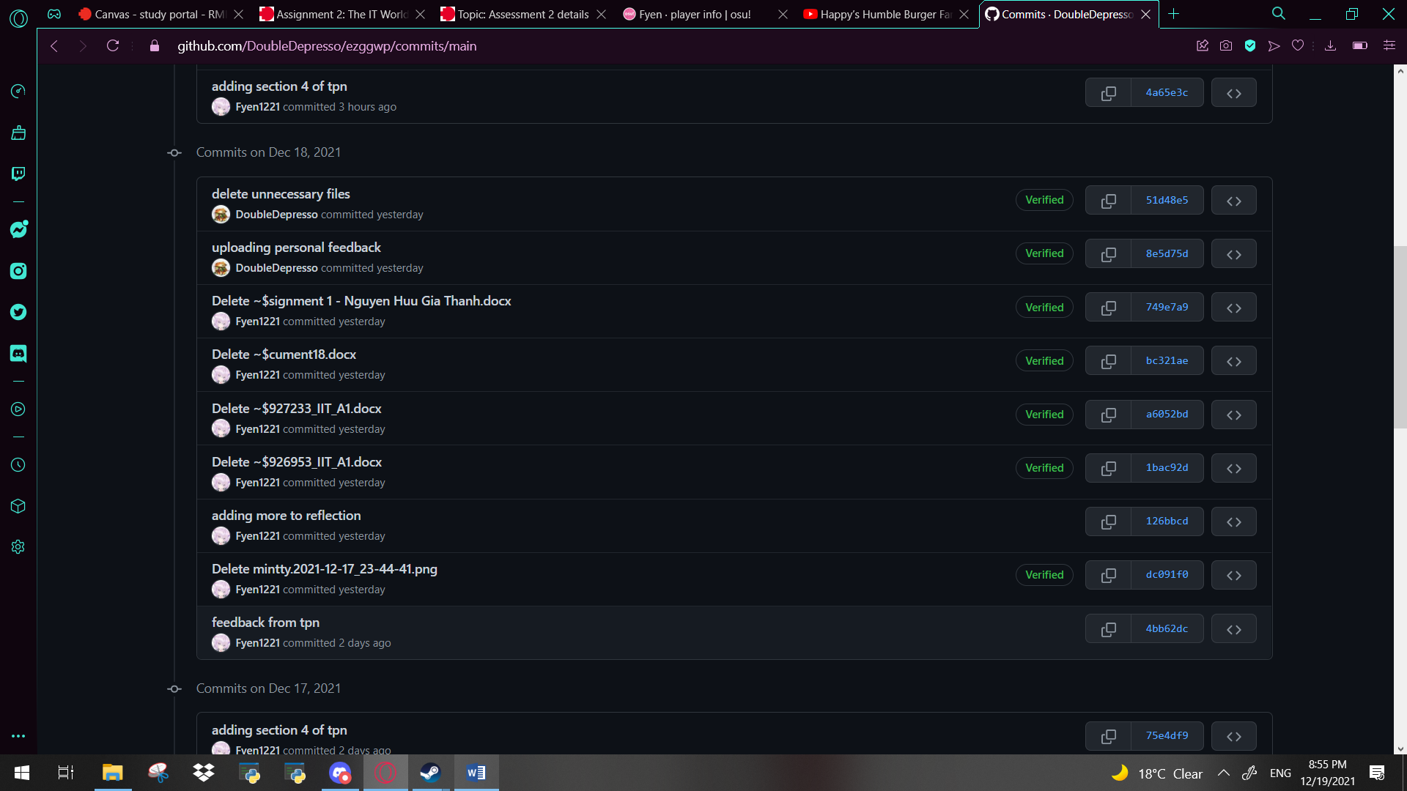

1. **IT Work:**

Our group has decided to interview an IT professional for this part of the work, the interview was done and written down by Bach Duy Doan as below:

*1. Please tell us about your IT work. What exactly do you do?*

I am a data analyst cum a data engineering.

*2. Please tell us about the industry you work in.*

The crossborder payment processor, e-wallet, and fin-tech.

Developing technology solutions to solve business problems

*3. What other kinds of work do you have to do?*

At present, I have no other types of work that I have to do

*4. Who are all the different people you interact with in your work? Please tell us about*

*them.*

CEO, CTO, developers, operation teams such as payment system teams, business development teams, monitoring teams, risk teams, etc.

*5. Please tell us about your interactions with other IT professionals.*

Meetings to receive tasks and requirements

Coordinating with dev teams to understand data structure and put them into data warehouses and process data to virtualize to business users.

*6. What about your interactions with clients or investors?*

I am not a business owner nor an IT service agency so I do not have clients or investors.

*7. What aspects of your work do you spend most time on? Please tell us about these.*

My tasks divide into 2 types of tasks: The first one is about discussing about solutions or technologies to boost the speed of data extraction, it could be interpreted as finding smarter and faster ways to store, read, write data. The second task is about virtualizing data by our virtualization based on requirements business users, we also provide inside deep inside from the data. I spend my time equally on each task.

*8. Which aspects of your work do you find most challenging?*

The most challenging part of the work is understanding the new technology that we apply because there are many technologies we have to select and try to test that do they fit with our current system and each of them has different ways to deploy so we have to read their document and test.

*9. Finally, can you share an example of the work you do that best captures the essence of*

*the IT industry?*

For example, we need to deploy a new solution to replicate the tables from my SQL and use new technologies to aggregate the data to boost up the loading speed of the query.

**Conclusion:**

After reviewing the answers given by the IT professional according to the questions asked plus a little research, we were able to come to a fair understanding of what their work actually is.

1. *What kind of work is done by the IT professional?*

The Professional that was interviewed above specifies in the field of data, not only that but data processing in the business world, ranging from cross border payments to e-wallet and fin-tech. Cross border payments are transaction conducted between people situated in separate countries and Fin-tech being new technology that aims to enhance and automate the delivery and usage of financial services. Which at its most basic level, is used to assist organizations, company owners, and individuals better manage their financial operations. Therefore, the majority of his work must be developing a way to manage data about transactions of the company he works for as well as maintaining it.

*2. What kinds of people does the IT professional interact with? Are there other IT professionals? Clients? Investors? The general public?*

As they have answered through our interview question above, most of the time they only have to interact with people relating closely to their work such as other teams in the company who also manages information that they could use for their superiors.

*3. Where do the IT professionals spend most of their time*

Because this industry requires a lot of work and plenty of time to manage, I reckon most professionals would have to spend their time at home or work place in front of their devices to finish their tasks. If not would be meeting up with teammates and other professionals to discuss their work

*4. What aspect of their position is most challenging?*

It is already answered clearly above about what things they find most challenging about their work. In a nutshell, it is mostly about picking what kind of software and technology works the best for them to deliver information, but each of them have a different way of getting deployed, so testing and eliminating each of them out must take a lot of time and effort.

1. **IT Technologies**

Each of our team members have decided on a topic to make researches about among the given ones in the assignment page as below.

**Blockchain and Cryptocurrencies**

Written by Gia Thanh Nguyen

**What does it do?**

Blockchain and Cryptocurrencies is now a hot topic around the world. Easily to be seen, in terms of blockchain, NFTs (Non-fungible Tokens) are the latest kind of cryptocurrency that are going trendy. To illustrate, NFTs transform a wide range of digital works of art and other collectible stuff into verified properties. Moreover, it can easily to be traded on the blockchain interface. However, the value of each cryptocurrency depends on the power of multi-media. In accordance with the impact of influencers, artists the value of the cryptocurrency can be up to a thousand to millions of dollars. Besides, the term “NFTs” may be new to some traders but the essence of it was found in many games that people must find rare digital items and trade them on groups or forums. The fundamental reason that NFTs come to phenomenon is because some people who want to support independent artists, however, others are appealed to the profit of cryptocurrencies which are driven by crypto millionaires and billionaires. For example, Elon Musk is the richest billionaire in the world and every tweet of him can affect the fluctuation of Bitcoin and other cryptocurrencies. Furthermore, NFTs and other cryptocurrencies are used as a means for the rich to launder money and evade taxes by creating NFTs themselves and re-purchase them by another identity.

There are a wide range of things that we can apply Blockchain to. First, Blockchain can help businesses to manage their activities by removing paper-based trails and pointing out the inefficiencies of their supply chains. By applying Blockchain to their supply chains, companies can keep track of their products as they travel from their original places to retailers. Second, regarding the rise of internet access, copyright of digital arts is a hot-button issue. People can easily get access to what they want whether they know it is legal or not. By using Blockchain, copyright laws would be more enforced. That every digital art will be encoded as a unique algorithm which the creators of these content will be purchased fairly. Third, as many sectors of healthcare have already moved to get away with using paper-based records, but Blockchain offers even more security and convenience. That a patient can keep their key of their medical records and share it to whoever they want. It is much safer for the patient to keep their information secure. Moreover, healthcare providers might potentially utilize blockchain technology to securely communicate information. This would cut down on redundancy and enhance diagnosis efficiency while also ensuring patient privacy. Finally, Blockchain might also be an effective way to back up your data. As we can see, Cloud is a reliable source to store your data, but it is not immune to hackers and malicious software. In contrast, Blockchain only permits those who hold the key chain to get access to the information, so it is much safer to use Blockchain as a backup for Cloud data centers. Soon, imagine that we can purchase everything quickly, houses for example, take a lot of time to make contracts and other verifications, can be handled easily by Blockchain through using smart digital contracts. Moreover, you might envisage a slew of new uses for blockchain technology in the real estate business, from accessible transaction information to asset recordkeeping to home automation that synchronizes with your lease terms.

**What is the likely impact?**

There is a diversity of potential ways that Blockchain and cryptocurrencies do have influence on society, and human life. First, every data transferred to Blockchain is validated and encoded, preventing this information from hackers and malicious viruses. Second, using a blockchain-based distributed system would make cloud technology more secure and immune to attacks. Second, Vehicles, houses, and even refrigerators are now part of the Internet of Things (IoT), which is made up of software, broadband connections, and gadgets. Hackers can gain access to autonomous cars when people are traveling or your house since these devices work from a crucial point that handles communications. Due to IoT technologies developing, blockchain has the capacity to resolve these fundamental security concerns, making it incredibly relevant. Third, Applying Blockchain to donation and charity is not a bad idea. To illustrate, Blockchain ensures that the money you give away can exactly go to where you need it to go. For example, Bitcoin-based donations have already created trust from donors by using smart contracts and letting them know their donations go through transparent and secure ledger.

On the other hand, because of the rise of Blockchain, a wide range of industries will be corrupted. First, Blockchain has a secure system that provides permanent records of millions of transactions around the world, this system can decrease the potential risk by providing immutable records. Moreover, money is transferred faster and cheaper than any conventional methods by the devolution provided by Blockchain. Second, the health care industry may be corrupted when it comes to sharing and storing information. As a result, many frauds, errors when transmitting information and lost records have caused distrust between customers and healthcare providers. On the other hand, by securely keeping patient files which can be accurately and safely transmitted to and accessed by physicians and other authorized individuals, blockchain technology can help rebuild confidence. Finally, because of its ability to store and authenticate documents and data, blockchain technology is set to disrupt several sections of the legal business. A lawsuit involving the resolution of issues about the wills of the deceased or any other paperwork, for example, can be avoided.

**How will this affect you?**

Regarding Thanh’s father has a disease, thanks to the development of IoT and Blockchain, all diagnosis and data of his can be exchanged easily by doctors. Moreover, drugs can be effectively distributed without any accumulated side-effects. Besides, Thanh also invests in Dogecoin, a kind of cryptocurrency, because he saw the potential of it as Elon Musk and a lot of “sharks” have invested in Dogecoin. A year ago, when he invested in another cryptocurrency: “DOT,” “the value of this coin fluctuated as my behavior, sometimes happy, sometimes frustrated simultaneously” he said. He always told his friend that “It is a long-term investment, and you will never know the potential of it.” However, when the value of “DOT” had drastically declined, his friend made fun of him so he began to be depressed and accepted that he might lose his money. However, after two months, the value of the coin surprisingly rose to the price ceiling then he earned 100% profit of it. Moreover, he tells us that investing in cryptocurrency now like gambling, “if you want to invest in something, at first, you must spend your time to broaden your knowledge.” he said. Another example, a friend of Thanh also invested in cryptocurrency, but he was not lucky like Thanh that he has lost a huge amount of money. As the rise of cryptocurrency and its potential, but more potential and profit come more risks, the youth are easily suffered from FOMO (Fear of Missing out), that people may get anxiety and depression if they feel others are having an enjoyable time without them. In addition, the temptation of money and properties may direct the youth to take risks.

**Cloud Computing**

Written by Bach Duy Doan

**1.What does it do?**

-Cloud computing is the state-of-the-art technology that enables users to store and access information and computing services such as Dropbox, Google App Engine, and Amazon Web Services through the internet rather than their computer's hard drive. There are many types of cloud computing, including Software as a Service (SaaS), Platform as a Service (PaaS), and Infrastructure as a Service (IaaS). There are several modern kinds of cloud computing such as Platform as a Service (PaaS), Software as a Service (SaaS), and Infrastructure as a Service (IaaS). To be specific, SaaS, or Software as a Service, is a cloud computing model used for distributing software via the Internet as a service. It helps users to access a myriad of types of software over the Internet rather than installing those. Moreover, PaaS, or Platform as a Service is a method used by third-party suppliers in order to provide hardware and software tools to individuals through the Internet. Furthermore, IaaS, or Infrastructure as a Service, is a type of cloud computing service that offers essential computing, storing, and networking resources in order to meet the demand of users and rely on particular bases.

-There are many uses of cloud computing that can be seen at present. Firstly, it helps people to protect the storage of their personal data, information, secures their privacy, reduces administrative costs and expenditure. It may also keep data private and secure and prevent those from being stealing hackers and types of data stealers. Moreover, it also makes it easier for people to access many types of data in order to help them to save time and money. To be specific, the Pay-as-you-go model (PAYG), is a payment method for cloud computing that provides exactly as much data storage space as individuals need so that users do not have to pay for unnecessary space. Due to a survey implemented by Bitglass in 2015, half of all CIOs and IT leaders polled indicated cost savings as a result of utilizing cloud-based applications. Besides, cloud computing offers people more flexibility overall versus hosting on a local server. For example, if users want to have additional bandwidth, cloud-related services may fulfill that kind of demand immediately, instead of spending time and money in order to have costly and sophisticated updates to their IT infrastructure. Moreover, it enables people to share and corporate information and data through devices such as computers and smartphones to stay in touch with other individuals, clients, and co-workers. Furthermore, it helps organizations to quickly recover from all types of emergencies such as power outages and natural disasters like blizzards, earthquakes, and tsunami. According to a recent survey, 43% of IT managers plan to participate in or enhance cloud-based disaster recovery systems and solutions.

-There are numerous potential cloud computing uses that may turn into reality in the next three years. Firstly, it might assist AI systems in generating greater amounts of data and information, having better computations, and managing resources better in order to meet the demand of individuals. Some factors such as the development of AI tools and innovative software make this possible. Moreover, due to the improvement of specialist solutions like BetterCloud and Cloud Manager, cloud computing may help users to administer solution suites in more efficient ways. Furthermore, thanks to the advancement of cloud services and applications related to cyber security, cloud computing will allow people to have better security choices in the coming years. Last but not least, it can be utilized by individuals to create more private cloud infrastructure in order to prevent users from the security and financial risks of using the public cloud.

**2. What is the likely impact?**

-There are many possible positive impacts of cloud computing. For starters, it may make it easier for individuals to recover and restore data, which is a very time-consuming process. Moreover, it might also allow people who are located in different locations to rapidly and effortlessly collaborate and share information and data in a very convenient and secure environment. Lastly, it possibly helps individuals, even those who are working at remote locations to have quick and easy ways to store information and data in a variety of situations and locations, as well as access cloud services via an internet connection.

On the other hand, there are also numerous negative impacts of cloud computing. Firstly, users who use cloud services may be opened up to cybersecurity risks such as data leakage, data loss, and data theft. Besides, technical problems happened in the cloud can cause damage to users and enterprises. Last but not least, the growing number of people who use cloud services may cause bandwidth issues which might bring negative impact to users.

-In my opinion, all impacts above can be changed in the future due to the rapid changes in cloud computing and other technologies related to it.

-There are many people who are positively affected by that development. Firstly, individuals who are project managers with particular IT experience can be headhunted in order to create and manage tasks related to cloud-based project management. Furthermore, people who are software developers may be necessarily needed by IT companies to create, maintain and update software related to cloud computing. Lastly, that development might keep cloud computing providers employed because of the growing need to manage, create and control cloud-based software systems.

On the other hand, there are also numerous individuals who are negatively affected by that development. For starters, a variety of database administrators may become redundant because that development might reduce the need for database administrators. Moreover, many people whose job is help desk support specialists may become unemployed because of the development of cloud computing

-The advancement of cloud computing may create new jobs in the near future. However, it might make redundant and replace some jobs such as help desk support specialists and database administrators

3. **How will this affect you?**

-In my opinion, that development may affect a member of our team in different positive ways and make many things different for him. Firstly, it possibly assists him in protecting the storage of my personal data, information, and ensuring my privacy. Moreover, it also makes it easier for to access various sorts of data to save him time and money. Besides, it might allow him to share and corporate information and data through devices such as computers and smartphones to stay in touch with other people. Lastly, it may enable him to store data on the Internet via a cloud computing service. For example, if he want to upload a variety of kinds of data such as my documents, photos, and music, he might just use cloud computing providers like ShareFile, Flickr, and Dropbox in order to suit his needs.

On the other hand, that development may affect him in some negative ways. For starters, by using cloud services, my data can be stolen and leaked. Furthermore, he may have less control over how cloud services work and are executed within a cloud-based infrastructure.

-That development, in my opinion, may influence his friends and family in many different ways. For starters, it may help them collect more data and information, improve computations, and manage data and information better in order to fulfill their demand. Moreover, it might allow them to administer solution suites in more efficient ways. Furthermore, it can be utilized by them to collaborate and share information and data in numerous situations and locations. On the other hand, the rapid development above possibly makes older members of his family like his father, his mother, his grandfather, and his grandmother feels confused when they use cloud services so that they may become perfect targets for hackers and other kinds of data stealers.

***AUTONOMOUS VEHICLE***

Written by Don Tuan Duong

Autonomous vehicle, also known as self-driving vehicles, is a vehicle that can sense its surroundings to move safely with little to no human interaction. The level of a vehicle autonomy can be described through the autonomous driving scale, which is made up of 6 different levels. The higher the level, the less human interaction upon the driving:

* **Level 0 (No Automation)**: The car has no autonomy, which means driver’s intervention is required at all time during the driving.
* **Level 1 (Driver Assistance)**: At this level, the Advance Driver Assistance Systems (ADAS) begin to seize the control of the vehicle in certain scenarios, but the appearance of a driver is still a requirement.
* **Level 2 (Partial Automation)**: With greater system awareness, the vehicle can do multiple complex action at once such as steering, accelerating and braking in some cases, but the driver still have to pay attention at all times during the drive.
* **Level 3 (Conditional Automation)**: The Automated Driving System (ADS) can do the majority of the driving operations in some certain situations; a driver is still a necessity in order to take back the control of the vehicle whenever the ADS requests
* **Level 4 (High Automation)**: The ADS is capable of handling all elements of driving in certain circumstances while the driver needn’t pay attention but still have the choice to step in.
* Level 5 (Full Automation): the vehicle can do all driving tasks regardless of the circumstances, a driver’s operation is not a requirement

Autonomous vehicles have been around a long time ago. In the 1939 World’s Fair, General Motors debuted the first ever self-driving car model. It was a vehicle that powered by electricity that took guidance from radio-controlled electromagnetic fields and magnetized metal spike buried in the road. From then, many famous car brand like Mercedes, BMW, Volkswagen… trying to make a modern self-driving car, but the most successful one is Tesla. Automated driving system is the most commonly seen in these smart cars. This system is a combination of a variety of other technology such as radar, cameras, ultrasound, and radio antennas to navigate its route and detect obstacle on its way, making the system more reliable and robust. For instance, Tesla’s driverless car technology, as known as “Autopilot”, uses 8 cameras that give a full 360-degree view up to 250 meters of range, while 12 ultrasonic sensors and a front-facing radar scan the surroundings for possible risks. The system gives you a view of the world that drivers alone can’t get, looking in every direction at the same time and on wavelengths that are well beyond human perception. You can even summon the car with Smart summons, which your car will navigate sophisticated environment and objects to come and to your location. Inside the car also provided with a big screen that display the scanned surroundings in a 3D view so the driver will know when to intervene. Although Tesla’s Autopilot system can assist your driving, enables your car to steer, accelerate and brake automatically within its lane, but still required the drivers’ attention. At the moment, most of modern vehicles are at level 1 of the autonomous driving scale, which have the ADAS to assist the drivers on the road for the best driving experience possible. Tesla is at level 2, which its ADS will take control of the vehicle in certain situation and make the driving tasks much easier to handle. There are still a lot of difficulties that scientists and car manufacturers have to overcome in order to make a fully automated vehicle. But with the continuous development of 5G and Artificial Intelligence, the possibility of an AI-controlled self-driving system put into practice in the next 10 years is very high.

With the constant development of self-driving cars, they will surely leave both positive and negative impact upon our lives. First of all, along with the development of autonomous vehicle, car manufacturers are also heading towards making electric-powered cars instead of traditional gasoline-powered cars. So, most of the self-driving cars in the near future will likely be powered by electricity, which will reduce the amount of carbon dioxide emissions and resolve the noise pollution problems in most big modern cities, resulted in cleaner air improve public health and living conditions for city dwellers. Second of all, autonomous vehicle will leave a major impact on the economy. With the appearance of self-driving cars, taxis drivers, deliveries drivers… are at risk of losing their job as the automated driving system will replace and fulfill their roles. However, the self-driving with easier and cheaper maintenance will help taxis and deliveries companies financially in prolong terms by cutting down on maintaining human resources. Furthermore, autonomous vehicle will surely improve people’s traveling experience. For example, with the self-driving cars, we will no longer have to drive the cars ourselves to work, instead we only need to sit in the vehicle for them to “deliver” us to work, while we can enjoy a cup of coffee and a relaxing morning on the car. The self-driving system will also reduce the amount of traffic jam due to the fact that these cars will communicate with each other inside their radius to predict and navigate the most optimal route to your desired destination. Thus, the self-driving system will surely reduce the amount of traffic accident since most of the accidents occur nowadays, the drivers are the one to be blamed. With the self-driving systems installed, driver’s errors can no longer be seen. And with the creation of autonomous vehicles, the government will have to make some changes toward the law regarding the usage of the vehicles’ self-driving system.

It is without doubt that the self-driving cars will make our life much easier: less traffic jams and accidents, improve the living conditions in big cities, make traveling less bothersome. But this technology is not something that I’m excited about for numerous reasons. Ever since I was a kid, I have been extremely fascinated with land vehicles, especially cars. In another way of saying, I am a car enthusiast. And as a car enthusiast, I find the concept of autonomous vehicle not very interesting. For instances, self-driving systems may hinder the “driving experience” that we can get from traditional cars. To me, driving is not just about getting to our destination, it is also about the excitement sitting behind the steering wheels. Sometimes, I just want to drive around, not going to any specific location, wandering anywhere you want, exploring new places by yourself. You can experience this kind of fun in a self-driving vehicle since it can only go to your inputted destinations. Moreover, cars that have self-driving system will definitely more expensive than those without the system, which means people with low financial income will not be able to afford such expensive items. Although I personally dislike the idea of autonomous vehicle, it will surely be a great thing for my family. My parents are not young anymore, soon they with age and their physical health will gone bad, and they might not be able to drive anymore. In this circumstance, the automated vehicle will surely come in handy for my parents to travel safely anywhere they want. Thus, the self-driving system can calculate the shortest and most optimal route to our destination so we can go anywhere we want in the shortest time possible.

**Natural language processing**

Written by Thai Phuc Nguyen

**I. Definition and a little history**

The initial definition of “Natural language processing” can be considered as another area of computing extended from linguistic, computer science and artificial intelligence which goes into the interaction between machines and the human language. Particularly in how to program a computer so that it could understand and process natural language

This fundamentals of this particular area in IT dates all the way back from the 1950s, when Alan Turing published an article titled “Computing machinery and intelligence”, introducing the whole concept to the public with one question “Can machines think?”, resulting to what we know today as the “Turing test”

**II. Main content**

*What does Natural language processing do and its relations to chatterbots*

Initially, you could think traditional Rule-based bots that only rely on option buttons, yes-no questions, keyword recognition, and quick answer suggestions can already generate exceptional answers to human’s question, but NLP (natural language processing) still pays an important role in the matrix of bots development.\

**A: The way NLP works**

To explain what NLP is, we can take the example of one of its very famous uses, which is the auto-correcting system found in almost every devices that you use to type words on, especially documenting and texting. This kind of software not just identify and correct the mistakes you make while typing, it can also predict or guess which words you want to type in next. This is achieved by giving the software a massive library of information and data about the language that we use, words, phrases, different sentences or even live transcripts of conversations or emails. And with this overtime, the machine itself could learn how to assemble the words together into meaningful sentences, and make sense of what we’re trying to deliver. But, all that is of course still much more simple than being able to naturally respond to a conversation with a human being.

Despite that, a computer’s understanding of natural language happens through the analysis of text or speech input using a hierarchy of classification models:

**+ Domain classifier**: divide a human’s input into sections into a pre-set group of conversational domains. This particular solution is only necessary for processing a conversation in which contains various different topics, each needing specialized vocabulary. One famous example of the ability to classify domains being essential for an AI is the virtual assistant Cortana of Microsoft. Domain classifiers seen from assistants such as Cortana are likely to include the weather, news, music and many others.

+ **Intent classifier:** exactly as its name suggests, it identifies the person's goal by assigning each input to one of the intents defined in your NLP system. These usually include “find the nearest store”, “find opening hours” and so on.

+ **Entity Recognizer:** acquire the data which are essential to achieving the user’s query/intent. For example, if the user wanted to book a flight, the required information under this intent would be the flight time, date or luggage.

+ **Role classifiers: are additional labels that you may attach to your entities to even further differentiate them if needed, such as classifying the time even more by labeling it as morning or afternoon.**

**Now with all that about the way NLP works, we can finally dive into the major factors that helps NLP based chatbots a reality.**

**B: The 3 Pillars of an NLP-based chatbot**

1) Dialog system

As far as communication goes, us humans use the very tools that the natural evolution has gave us for thousands of years, our mouths to speak, our ears to listen, our fingers to type and our eyes to read. Obviously, chatbots will need an appropriate interface that is compatible with the way humans retrieve and give information through communicating. Which is what exactly called a Dialog system.

For such system to actually work as it intends to, it has to be proficient of producing output and receive input. Other than that, they can acquire a variety of forms. You can differentiate them based on:

* Modality (text-based, speech-based, graphical or mixed)
* Device
* Style (command-based, menu-driven and - of course - natural language)
* Initiative (system, user, or mixed)

2) Natural Language Understanding

It is essential to point out that the ability for bots to interpret what the user is saying is still one of the, if not the biggest weakness of an NLP based chatbot. Due to the immense complexity of the human language, the massive vocabulary along with words that has multiple meanings that are completely different from each other.

Therefore getting the NLU (natural language understanding) right on these bots are much more important than making them sound as human-like as possible because in the end, the user could care less about the ecstatic of the software when it produces the answers they need. Nobody will notice if a bot can't deduce meaning from natural input effectively, even if it has the smoothest small conversation abilities.

3) Natural Language Generation

Now that after a bot has got a decent understanding of whatever the input is given by the user, they got to be able to produce an appropriate response and translating it into human language, which requires NLG (Natural Language Generation).

The framework of the material must be established for the NLP to generate a human-friendly narrative, whether through rules-based workflows, templates, or intent-driven techniques. To put it another way, the bot needs something to work with in order to produce that output.

As of today, almost every NGL system relies heavily on narrative design, aka conversation design which is a synthesis of many design disciplines including voice user interface design, interaction design, visual design, motion design, sound design, and UX writing to produce an output.

***What is the likely impact that NLP and chatterbots would have on the development of technology?***

**In recent times, many would argue that NLP based chatbot would be completely unnecessary considering its practicality when it comes to improving a businesses for say, because simple and straightforward tasks only needed to be done by the press of a single click hence why it is not needed to make the user type out or say what they want. For a matter of fact, if used inappropriately, chatbots could hurt one’s business more than doing any good.**

**So using chatbots for anything rather than messing around for entertainment such as “Eve” is not going to be really any better than seeing and talking to an actual human employee to get support.**

**Needless to say, despite that I still think further developing this kind of technology would be extremely fascinating, since technically modern day chatbots can already convey very meaningful conversations with a human being and even with each other, it may not be practical yet but with it still growing each day, perhaps service jobs could be replaced by bots that can converse with people just fine, ensuring the satisfaction of the customer. The possibilities are actually much more if you use your imagination enough.**

1. **Project idea**

This conclusion of our project idea was put together by Bach Duy Doan

**Overview:**

**-**Our group planned to make an adventure game in Unity named Garen. There will be a hero named Garen in the game, and his purpose will be to prevent the planet from being destroyed by monsters. Moreover, we will utilize computer programming basics and C# coding language to build this game. Finally, in order to attract a large number of players, the game will be distributed on both the iOS and Android platforms.

**Motivation:**

-For starters, Garen may assist players in improving their problem-solving abilities when combating enemies. Moreover, it can also help individuals to improve their auditory awareness and hand-eye coordination. Last but not least, they can play this game to relax after a stressful studying or working day.

**Description:**Our group intends to do the following steps to create the game's model:

1. Practising and gaining necessary knowledge about the C# coding language C# coding language.

2. Learning and acquiring useful information about the basics of computer programming for Unity development.

3. Making and configuring a Unity project to build Garen.

4. Designing the pictures of items, monsters, and the appearance of the hero, a burly warrior with sturdy armor and a keen sword.

5. Adding empty scenes in which the battles will happen.

6. Using Sprite to make a GameObject

7. Making adjustments to GameObject and saving them

8. Creating and decorating maps of multiple levels to make the game more attractive to gamers

9. Creating the story of the hero

10. Making conversations between the NPCs and the hero in order to make the game more vibrant and enable gamers to gain useful information about the world in the game.

11. Adding variables to the hero and enemies in the game.

12. Making rudimental tutorials in order to help new players to understand the basics of the game.

13. Generating available awards for players once they defeat monsters and complete a level.

14. Utilizing the C# coding language to make and vary the movement of Garen, NPCs, and monsters in the game

**Tools and Technologies:**

- Our group plan to use several tools and technologies in order to create Garen. For starters, we choose Unity since it is a well-known and popular game creator. Furthermore, its user-friendly design makes it simple for us to use. Moreover, it also offers users a variety of resources such as accessible assets and free courses for beginners. The C# coding language is the second tool since it is used to create all motions and interactions of many games. Finally, we will utilize art production software in order to create and decorate digital arts and images for Garen.

**Skills Required:**

-Having necessary knowledge about Unity.

-Knowing essential C# programming skills.

-Having requisite skills for drawing and designing artworks and graphics for each component of the adventure game utilizing art creation software

- Having essential knowledge of systems of 3D/2D games

- Having necessary teamwork skills.

**Outcomes of the game:**

-The first outcome comes from gamers and streamers who will play Garen on online video sharing applications and social platforms

-The second outcome may relate to commercials in the adventure game.

-The third comes from selling items and outfits to gamers.

-The fourth may come from selling Garen to individuals through online retailers like App Store and Google Play.

1. **Feedback**

**Feedback from Gia Thanh Nguyen:**

* **Nguyen Huu Gia Thanh:** I am a leader of this team. As a result, I have equally divided sections for the team’s members. Every day during the project, I remind the members of their work and the deadlines. Sometimes, I was quite offensive and hotheaded, but I just wanted a good mark for everyone. After working as a team, I deeply know my teammates’ advantages and their drawbacks. Therefore, in the next projects, I am able to divide tasks more wisely that can take advantage of their strengths.
* **Thai Phuc Nguyen:** He is a kind-hearted person, every time I am struggle with something, he is always there and help me to complete my task. His biggest drawback is that he always accepts everything easily and does not want it to be better. However, if I ask him to change and make his tasks better, he is always willing to do that.
* **Don Tuan Duong:** Duong is a creative person that during the assignment, he produced a lot of ideas. Moreover, he helped me to use GitHub and I really appreciate that. Sometimes, I had conflicts with him due to the projects, but after that we became more sympathetic and acquired the way each other works.
* **Doan Duy Bach:** He always finishes his tasks on time and his works are absolutely accomplished through his hand. He takes responsibility for describing our project ideas and to my mind, he did very well.

**Feedback from Bach Duy Doan:**

* In my opinion, our group is a great team and I am really pleased with the excellent dedication and collaboration of all members of the group in order to complete this assignment.

**Feedback for Nguyen Huu Gia Thanh:**

* In my opinion, he is very hard-working and assiduous. As a result, he is a valuable member of our group. Moreover, I could see how much great effort he put into helping our team to finish this assignment. Lastly, he is an erudite person and he usually provided us with useful advice about our work in the assignment.

**Feedback for Don Tuan Duong**:

* I think Duong is a creative individual because when he collaborated with us on this assignment, he came up with some interesting ideas related to it. Moreover, he also had quite a lot of knowledge about autonomous vehicles so that we let him do about that topic in section 4 of the assignment.

**Feedback for Thai Phuc Nguyen:**

* To my mind, he is quite an enthusiastic person because he always tried to complete assigned tasks. Moreover, he is also a friendly member since it is easy to work and collaborate with him.

**Self-feedback:**

* In my opinion, I am the ideas generator of the team because I was in charge of accomplishing section 5 of the assignment. Furthermore, to my mind, I am a punctual person because I usually finished the assigned task on time.

**Feedback from Don Tuan Duong:**

**General feedback:**

In summary, I think our group has worked really well together, each group member has fulfilled their roles and dedicated the most of themselves for the sake of the team.

**Personal feedback:**

I was put in charge of website developing and GitHub management for the group. Although I tend to lose focus and laze around from time to time, I still try my best to complete the jobs given to me and instruct my team on how to use GitHub.

**Doan Duy Bach feedback:**

Bach is a punctual person who always turn in his works even before the deadline. Although he submits his works very soon, it is by no means that they are sloppy or uninformative. Thus, he is very communicative as well, which makes collaborating with him easy.

**Thai Phuc Nguyen feedback:**

Me and him have been each other’s acquaintances long before we attend RMIT, so we have planned to work with each other since the start of the first semester. The time spent working with him has been truly great, we help each other out in every way possible so we can pass the subject with flying colors.

**Nguyen Gia Thanh feedback:**

He can be considered as the leader and the most valuable member of our group. He is a very hard-working and a trustworthy groupmate. Thanks to him, our groupworks are very well organized and maintained. Furthermore, thanks to him bringing up face-to-face discussions among the team, we can help each other do the assignment more quickly and with better results. He is very disciplined and dedicated to make us push ourselves beyond the limit.

**Feedback from Thai Phuc Nguyen:**

Overall, I think us 4 as a team works really well together, each person knowing exactly what their tasks are and what they need to do as well as make research of to make sure our assignment is done with success.

**For Nguyen Gia Thanh:** This guy definitely identifies as the true leader of our group, it was thanks to him that our work is well organized and done with ease, he was always the one bringing up discussions and team meet ups that are needed for us to come to an agreement on what to do for our work. Always very focus, discipline and dedicated to make sure we get the most out of ourselves.

**For Don Tuan Duong:** Me and Duong has known each other way before I got into rmit. And finally getting to work with him as a team in college is truly a great experience. He has always helped me to understand school work much better than I could done myself, he has a very funny and lighthearted approach to problems I encounter, which makes me feel comfortable and at ease most of the time.

**For Doan Duy Bach:** This guy takes very well responsibility for his work, he always does things on time and also does it really well, nothing more we could ask from what he delivers after given a task by our leader.

**Self-reflection:** I would say I did a well enough job to deliver what I’m assigned to do in the group project, although I’m not as strict to myself on deadlines as the others, I tend to cramp a lot of the work to the very last day but I always try my best to make it before it’s too late.